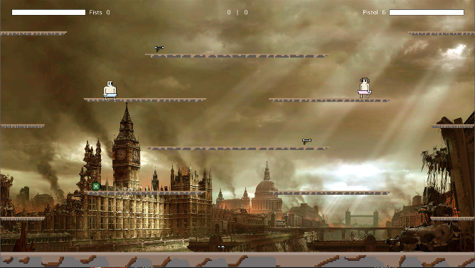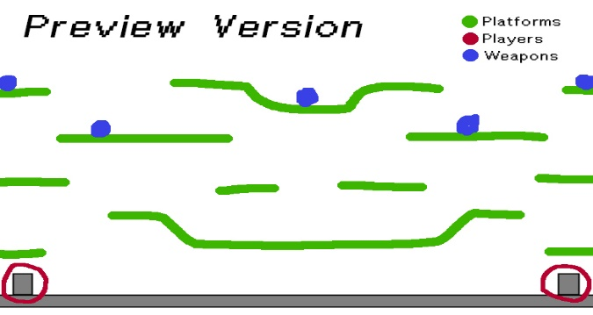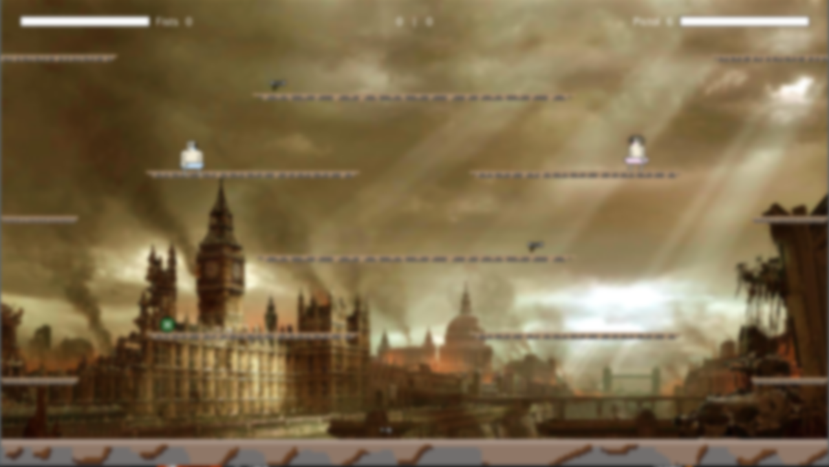

**After**

**Before**

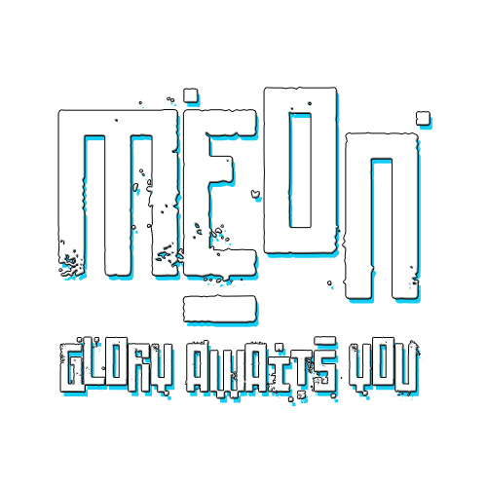

* **Controller support;**
* **Jump around;**
* **Move around;**
* **Grab power-ups;**
* **Dodge your enemy;**
* **Use your fists;**
* **Fire bazookas;**
* **Pick-up rifles;**
* **Shoot pistols;**
* **Be invincible.**



**Do all of the above and more on this brand new fast-paced, action-packed, 1v1 platform shooting game by Ana Rita Lamelas and João Fonseca.**

**Don’t blink.**